#Regex Extract mail.id

import re

s = 'My name is Conrad@gmail.com, and blahblah@gmail.com is my email@in.in.'

domain = re.findall("[\w.]+@[\w.]+\.in", s)

print(domain)

Otherwise, other alternative expressions would be:

[\w.]+@\w+\.(?!com)[a-z]{2,6}

or,

[\w.]+@\w+\.(?!com)[a-z]+

or,

[\w.]+@\w+\.(?!com)[a-z0-9]+

or with a looking ahead to space or end of the string,

[\w.]+@\w+\.(?!com)[a-z]{2,6}(?=\s|$)

depending on how your inputs may look like.

[Demo 2](https://regex101.com/r/rTfePI/1/)

Another option would be to swipe every [A-Za-z0-9_.] after the @ and exclude those with .com, and then looking ahead to space or end of string:

[\w.]+@(?:[\w.](?!\.com))*(?=\s|$)

[Demo 3](https://regex101.com/r/rBY08V/1/)

RegEx Circuit

[jex.im](https://jex.im/regulex/#!flags=&re=%5E(a%7Cb)*%3F%24) visualizes regular expressions:

[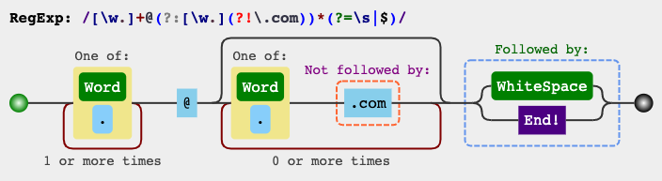](https://i.stack.imgur.com/nPDgK.png)